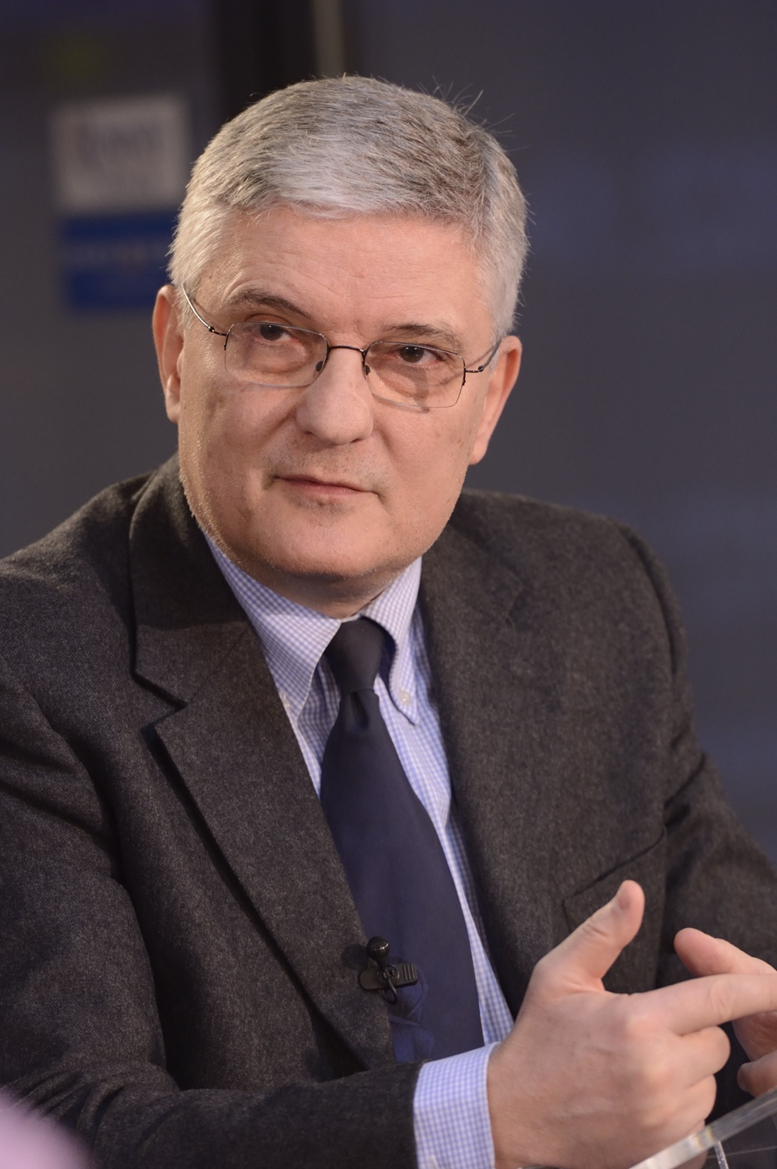

Daniel Daianu
Daniel Daianu is a professor of economics at the National School of Political and Administrative Studies (SNSPA) in Bucharest, and chairman of the Romanian Economic Society. He is a former finance minister of Romania and former Member of the EP. He was a visiting professor at UCLA and University of California, Berkeley.

